Dear Father,
We are delighted to offer the SmartLoving Marriage Seminar to couples in the broader Sydney region this year in (month).
Formerly called ‘Celebrate Love’ the seminar has been renewing marriages for over twenty years throughout Australia, New Zealand, UK and USA. It is effective for both loving stable marriages looking to deepen their intimacy as well as troubled ones.
More information about all our programs can be found at www.SmartLoving.org and you will also receive some communication from our local couples to promote the weekend.
We would be most grateful if you could advertise the seminar in your parish bulletin over the coming weeks using the advertisement below.
In Faith and In Love
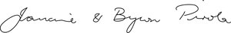
Francine & Byron Pirola
Directors of Marriage Formation
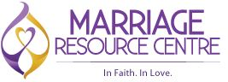
Parish Bulletin Advertisement

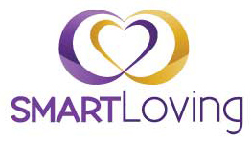
Because Every Marriage Matters
Suburb| Date
You want your marriage to be the best … committed, intimate,
joyful and passionate. Presented in a Catholic context,
the SmartLoving Marriage Seminar is a private experience
open to married couples of any faith.
Whether you’ve been married for one year or fifty years,
if you long for deep, satisfying, intimacy with your spouse,
this seminar is for you.
Proven results | Private and confidential | Spiritually sound

$95 per couple | Meals included
www.smartloving.org | 02 9319 6280 | info@marriageRC.org

